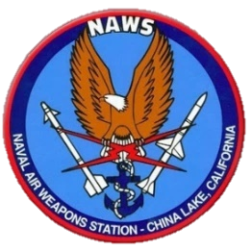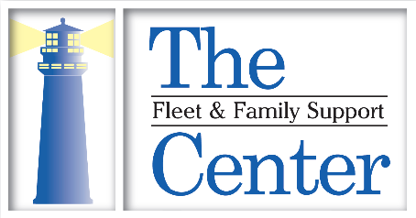

Reservations required for all workshops 1 week in advance.

Workshops can be scheduled virtually by request.

**VIRTUAL CLASSES**

**IN RED**

**OCT, NOCT, NOV, DEC 2025 │ NAWS CHINA LAKE** **FFSC QUARTERLY CALENDAR**

**FFSC DESERT COMPASS**

**GUIDING CHINA LAKE THROUGH EVERY SEASON**

**FAMILY EMPLOYMENT READINESS PROGRAM (FERP)**

**Acing the Interview**

Make your dream job a reality! Gain information and resources to develop expert interview skills.

**Dec 18 • 10 AM** │ **Nov 13 • 2 PM**

**Career Exploration**

Take a career assessment to determine which careers fit your personality and skills. FFSC can help you find jobs that will follow your spouse through their career in the Navy career.

**Oct 15 ● 2 PM │ December 3 ● 10 AM**

**Career Networking**

Explore the art of strategically making connections and building relationships that will bring more opportunities into your life.

**Oct 15 ● 3 PM**

**Entrepreneurship Pursuit of Self-Employment**

Discover how your strengths and life goals can align with successful business ownership. Uncover fundamental tools and strategies for launching and growing a small business.

**Oct 21 ● 10 AM**

**Job Search Strategies**

Are you looking for employment? Learn to find, federal, state, county, local, or remote jobs.

**Oct 28 • 8 AM │ Dec 23 • 2 PM**

**MWR Resume**

Looking for a job with MWR? Learn the process of getting hired at MWR including how to create a resume that will stand out to MWR hiring managers.

**Nov 19 ● 3 PM**

**Navigating Federal Employment**

Get the latest information and resources to navigate the federal employment process. Learn tips from the experts on how to create the perfect federal employment resume.

**Oct 29 • 4 PM │ Dec 17 • 2 PM**

**Tailoring a Resume**

A resume is the key to obtaining interviews. Fleet and Family Support Centers can help make sure your resume advertises your skills and abilities. Wow employers with an organized, effective, and winning resume.

**Nov 19 ● 2 PM │ Dec 23 ● 10 AM**

**DOMESTIC VIOLENCE AWARENESS**

**Purple Thursdays**

This October build Domestic Violence Awareness by wearing purple every Thursday. The purple ribbon is a symbol of courage, survival, honor and dedication to end domestic violence. Purple ribbons are available at FFSC.

**End the Cycle of Domestic Violence Challenge**

Join FFSC and MWR Fitness for an empowering 7 mile ride! Pedal with purpose to raise awareness. Participants are encouraged to aim for 7 miles. It takes an average of 7 attempts for a survivor to leave their abuser and stay separated for good.

**All month long**

**Domestic Violence Proclamation**

**Oct 07 ● 2:30 – 3:30 PM**

**Wellness Walk**

Get outside, breath fresh air, and read positive affirmations posted along Blandy Ave.

**Oct 27th – 31st**

**Empower Yourself: Self Defense for Domestic Violence Awareness**

Join FFSC and Force Protection at MWR Fitness Studio for a special self-defense class. This empowering session is designed to help you learn practical self-defense techniques to stay safe. Support survivors and advocate for change. Participation is free! Participants must be 13 or older. Location: MWR Fitness Studio, next to the NEX. Bldg. #19, China Lake, CA

**Oct 15 ● 4 – 5 PM**

**24/7 FAP Victim Advocate: 901-930-8354**

**National DV Hotline: 1-800-799-SAFE(7233)**

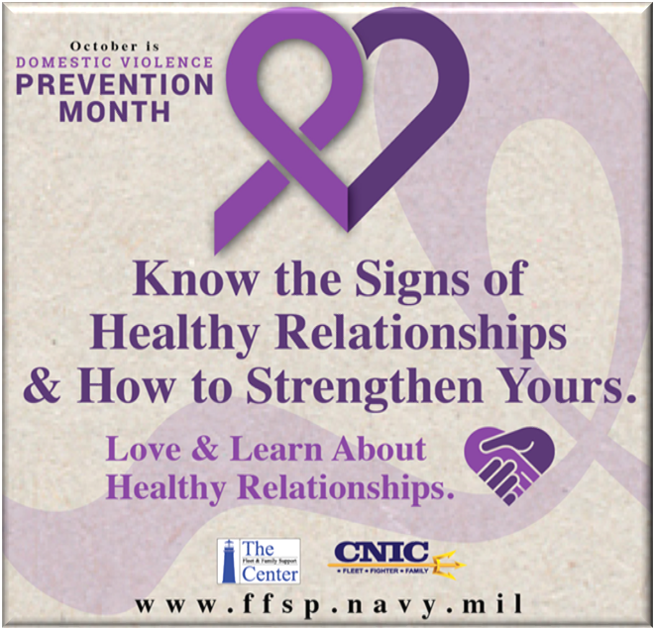

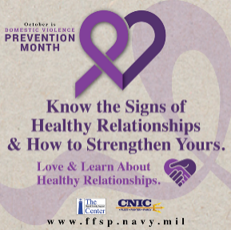

**chinalake.navylifesw.com | 760-939-4545 | NAWSCL_FFSC@US.NAVY.MIL | Bldg. 02308 Blandy Ave.**



**FFSC FAMILY FUN WINTER SERIES**

The Winter Series will feature a variety of fun activities for our military families!

**Every Tuesday in December and January**

**Dec 02 ● 10 AM – 12PM | Crafting & Games | Liberty Housing Office**

**Dec 09 ● 10 AM – 12PM | Crafting & Games | FFSC Childrens Playroom**

**Dec 16 ● 10 AM – 12PM | Family Fun Games | Mirror Lake**

**Dec 23 ● 10 AM – 12PM | Crafting & Games | Liberty Housing Office**

**Dec 30 ● 10 AM – 12PM | Crafting & Games | FFSC Childrens Playroom**

**OCT, NOV, DEC 2025 │ NAWS CHINA LAKE**

**FFSC DESERT COMPASS: GUIDING CHINA LAKE THROUGH EVERY SEASON**

**TRANSITION ASSISTANCE PROGRAM**

**TAP Class 3 Day Core Curriculum**

TAP provides separating/retiring service members and their families with the skills, tools and self-confidence necessary to successfully re-enter the civilian work force, pursue higher education, or technical training. This class is your compass for a smooth journey into civilian life.

**Sept 29 - Oct 1 │ Dec 8 - 10**

**TAP TRACK: Education**

This course is for anyone pursuing an undergraduate or graduate degree, includes information on choosing a field of study, selecting an institution, gaining admission, and funding your education.

**Oct 2 - 3**

**TAP Track: Employment**

Comprehensive employment workshop covering best practices in career development, including learning interview skills, building effective resumes, and using emerging technology to network and search for employment.

**Oct 2 - 3 │ Dec 11 - 12**

**TAP Track: Entrepreneurship**

Interested in exploring business ownership or other self-employment opportunities? Learn about evaluating business concepts, developing a business plan, accessing start-up capital, and contracting opportunities

**December 11 - 12**

**FAMILY ADVOCACY PROGRAM (FAP)**

**Healthy Relationships & Teen Dating Violence Prevention**

It’s never too early to talk to your child about healthy relationships and dating violence. Put your teen on track to manage a healthy relationship, understand boundaries, and recognize signs of abuse.

**Oct 07 ● 2 PM**

**Identification and Reporting Intimate Partner Violence**

Discover how the Navy addresses intimate partner violence to strengthen family health and readiness. Learn about prevention strategies, mandatory reporting, and supporting victims.

**Oct 02 ● 2 PM**

**Identification and Reporting of Child Abuse and Neglect**

Find out how the Navy addresses child abuse and neglect. Learn about prevention strategies, mandatory reporting, how to recognize and how to report signs of child abuse and neglect.

**Dec 23 ● 2 PM**

**Family Advocacy Program Overview**

Overview of the Family Advocacy Program (FAP) prevention and intervention process.

**Oct 8 ● 2 PM │ Nov 10 ● 2 PM** │ **Dec 10 ● 2 PM**

**FAP Leadership Orientation**

This 1.5 - hour training provides an overview of the Family Advocacy Program, the Sailor Assistance & Intercept for Life (SAIL) program, a review of Problematic Sexual Behavior in Children & Youth (PSB-CY) policy and MDT meeting requirements.

* *Fulfills OPNAVINST 1752.2C, for new Commanding Officers to be oriented to the Family Advocacy Program in the local area within 90 days of assuming command.*
* *Fulfills annual training requirements for Senior Enlisted Advisors.*

**Oct 8 ● 3PM │ Nov 12 ● 3PM** │ **Dec 10 ● 3PM**

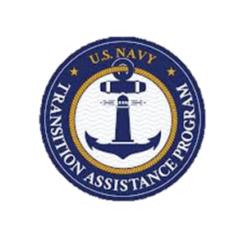

**OCT, NOV, DEC 2025 │ NAWS CHINA LAKE**

**MIND BODY MENTAL FITNESS PROGRAM (MBMF)**

Learn to enhance the mind, body, spirit, and social domains in one's life. MBMF teaches proactive pathways to achieve mental fitness and gives you the tools to manage stress.

**Oct 7 ● 2 PM Module 6: Connection**

**Nov 4 ● 2 PM Module 1: Stress Resilience**

**Nov 12 ● 2 PM Module 2: Mindfulness**

**Nov 18 ● 2 PM Module 3: Living Core Values**

**Nov 25 ● 2 PM Module 4: Flexibility**

**Dec 2 ● 2 PM Module 5: Problem Solving**

**Dec 9 ● 2 PM Module 6: Connection**

**FFSC DESERT COMPASS: GUIDING CHINA LAKE THROUGH EVERY SEASON**



**SEXUAL ASSAULT PREVENTION AND RESPONSE (SAPR)**

**SAPR Command Duty Officer Training** (offered quarterly)

If you are a Command Duty Officer, please join your SAPR program to receive your quarterly update on policy changes, updates to SAPR services and procedures, and obtain the resources needed to help those you support.

**Oct 16 • 2 PM**

**Sexual Assault Response Program Command Leadership Training**

This 1 - hour training fulfills the SAPR training requirements for OPNAVINST 1752.2C for new Commanding Officers, Executive Officers, Senior Enlisted Leaders, or Officers in Charge to be oriented to the SAPR program at NAWSCL within the mandatory 30 days of assuming command.

**Oct 15 • 12 PM │ Nov 14 • 12 PM │ Dec 15 • 12 PM**

**Sexual Assault Case Management Group (SACMG) Training**

Are you a new Commanding Officer, Executive Officer, Senior Enlisted Leader, or Officer in Charge at China Lake? Or do you need your yearly SACMG refresher training? In addition to the Commander’s Toolkit Training, this training will orient you to your responsibilities and the process of the SAPR Case Management Group. Fulfills CINCINST 1752.4 requirements and is required prior to attendance of SACMG.

**Oct 15 • 11 AM │ Nov 14 • 11 AM │ Dec 15 • 11 AM**

**Sexual Assault Prevention and Response (SAPR)– Spouse Orientation**

Overview of the SAPR program for dependents (over 18) and spouses of Service members. Know your options, resources, intervention skills, and receive information on how you can support others who experience sexual violence.

**Oct 6 • 11 AM │ Oct 6 • 2 PM │ Nov 3 • 11 AM │ Nov 3 • 3 PM │ Dec 8 • 11 AM │ Dec 8 • 3 PM**

**OMBUDSMAN PROGRAM**

**Ombudsman Training (OBT)**

**In person**

Mandatory **17.5-hour** course provides Ombudsmen with the knowledge, skills and resources needed to be successful in their volunteer role. This workshop is open to newly appointed Ombudsman, current ombudsman, and command point of contacts.

**Must attend all workshops for Ombudsman certification**.

Registration ends Oct. 20

Contact Deborah Edwards 760-939-4553,

**Nov 1 • 8:30 am-1 pm**

**Nov 2 • 8:30 am-1 pm**

**Nov 8 • 8:30 am-1 pm**

**Nov 9 • 8:30 am-1 pm**

**OCT, NOV, DEC 2025 │ NAWS CHINA LAKE**

**EXCEPTIONAL FAMILY MEMBER PROGRAM (EFMP)**

**EFMP Coffee & Chaos**

Bring your little ones to play while you have coffee and learn about advocacy tips for parents of children in EFMP.

**Oct 1 ● 4 PM │ Nov 5 ● 4 PM │** **Dec 3 ● 4 PM**

**EFMP POC Training**

Commands will learn to develop and establish an EFMP Point of Contact program. EFMP POC’s support EFMP families by providing enhanced communication, information, and referral to Medical and Fleet & Family services.

**Oct 16 ● 12 PM │ Oct 22 ● 3 PM │**

**Nov 14 ● 9 AM │ Dec 2 ● 9 AM │ Dec 12 ● 3 PM**

**EFMP: 504 and IEP What do they mean?**

This workshop addresses the differences between 504 plans and Individual Education Plans (IEP) and how to advocate for your child to receive the proper services needed for their individual needs.

**Oct 9 ● 12 PM │ Dec 17 ● 8 AM**

**EFMP: Resources & Support**

Come and gain valuable insight into the EFMP program and resources needed to support your EFMP family member. Learn and share tips with other EFMP families.

**Oct 15 ● 8 AM │ Nov 18 ● 8 AM │ Dec 11 ● 1 PM**

**FFSC DESERT COMPASS: GUIDING CHINA LAKE THROUGH EVERY SEASON**



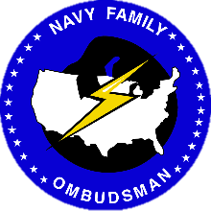



**Welcome to China Lake Brief**

Connect with fellow military families, explore local hidden gems, and dive into valuable insights on military programs. Get resources for foreign-born spouses and new spouses to the Navy. Let’s build a supportive community together.

**NOW AVAILABLE VIRTUAL or IN-PERSON**

**Oct 17 ● 1 PM │ Oct 17 ● 1 PM │ Nov 12 ● 12 PM │**

**Nov 20 ● 3 PM │ Dec 16 ● 9 AM │ Dec 16 ● 9 AM**

**SUICIDE PREVENTION**

Learn how to utilize the power of effective communication as a vehicle for enhancing relationships at work and at home.

**Nov 5th ● 10 AM**

**FFSC DESERT COMPASS: GUIDING CHINA LAKE THROUGH EVERY SEASON**

**OCT, NOV, DEC 2025 │ NAWS CHINA LAKE**

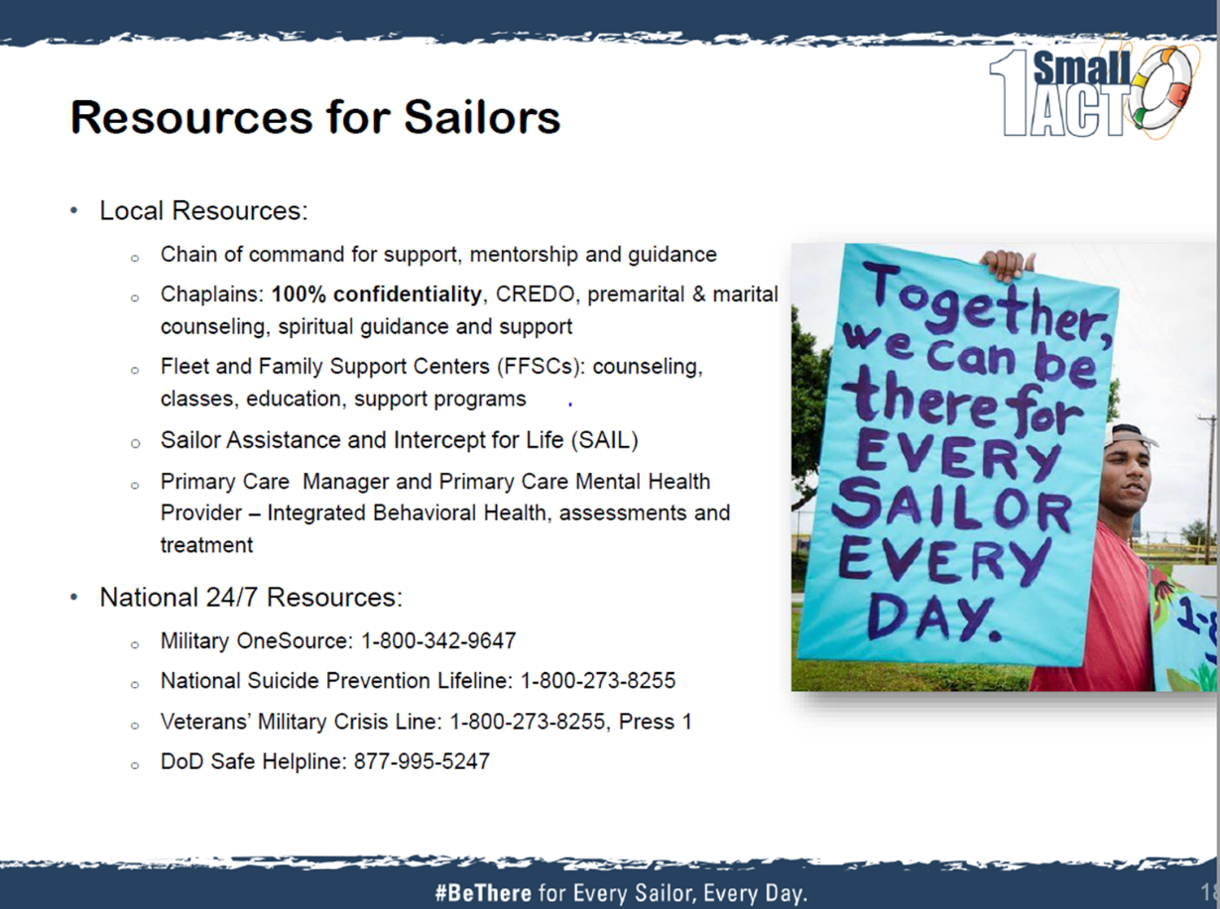



**LIFE SKILLS**

**ACTIVE PARENTING: FIRST 5 YEARS**

**Pre-Registration is required**

Parents and caregivers of littles, this class is for you. Learn child development principals along with age-appropriate behaviors utilizing ages and stages in this 4-part interactive series. We will focus on encouraging positive behaviors, preventing problems and learn methods for positive discipline.

**Nov 17th ● 1 PM Session 1: You and Your Child**

**Nov 18th ● 1 PM Session 2: Preventing Problems**

**Nov 19th ● 1 PM Session 3: Encouraging Positive Behavior**

**Nov 20th ● 1 PM Session 4: Preparing for School Success**

**Anger Management**

Learn to address signs and symptomsof anger mismanagement, identifyeffective ways to express anger,and identify resources available toassist in changing destructive anger relatedbehaviors.

**Oct 14 ● 10 AM**

**Conflict Management**

Apply collaborative problem-solvingtechniques to create positive outcomesfrom conflict situations.

**Nov 12 ● 10 AM**

**Effective Communication Skills**

Learn how to utilize the power of effective communication as a vehicle for enhancing relationships at work and at home.

**Oct 8 ● 10 AM**

**Holiday De-Stress Series**

Holidays often come with the stress of family gatherings that are rarely stress-free. During this three-part series workshop, we will explore a number of ways to reduce stress during the holiday season.

**Nov 6 ● 3 PM Reducing Holiday Stress**

**Nov 13 ● 3 PM Minimizing Family Conflicts**

**Dec 4 ● 1 PM Establishing Healthy Boundaries**

**RELOCATION (RELO)**

**Sponsorship Training**

Pre-registration is required. We will discuss the benefits of a successful sponsorship program and review the roles and responsibilities of command sponsors.

**Oct 17 ● 10 AM**

**Nov 25 ● 2 PM**

**Dec 2 • 3 PM**

**FINANCIAL MANAGEMENT PROGRAM (PFM)**

**CFS Quarterly Forum**

Explore the four pillars the PFM program: education, counseling, consumer advocacy, and information & referrals. This training is open to all CFSs, senior enlisted advisors, and command career counselors. Additional CFS Course Dates Available Upon Request.

**Nov 18 ● 3 PM**

**Consumer Awareness**

Master the art of deterring, detecting and defending against consumer fraud. Learn to identify and protect yourself from misleading and fraudulent consumer practices.

**Dec 16 • 2 PM**

**Home Buying**

Determine if you are ready to purchase a home. Learn how to choose a real estate agent and mortgage.

**Oct22 ● 1 PM │ Dec 10 ● 3 PM**

**Paying off Student Loans**

Learn about the student loan management options available to you and how to take steps to apply repayment options to your loans.

**Oct 20 ● 3 PM**

**Planning for Your Retirement**

Learn to estimate retirement needs, understand military retirement plans and evaluate retirement account options.

**Nov 4 ● 10 AM**

**Raising Financially Fit Kids**

Examine your own financial skills and behaviors to determine how to best implement age-appropriate sound financial practices for your children.

**Nov19 ● 10 AM**

**Savings & Investing**

Come discuss the purpose and value of saving and investing, then learn to evaluate and choose appropriate tools and techniques to build wealth.

**Oct 20 ● 10 AM**

**Thrift Savings Plan (TSP)**

What are the Benefits of participating in the TSP? What is the difference between traditional and Roth TSP options? Learn how the Thrift Savings Plan (TSP) can contribute to your financial security during retirement.

**Dec 4 ● 10 AM**

**FFSC DESERT COMPASS: GUIDING CHINA LAKE THROUGH EVERY SEASON**

**OCT, NOV, DEC 2025 │ NAWS CHINA LAKE**

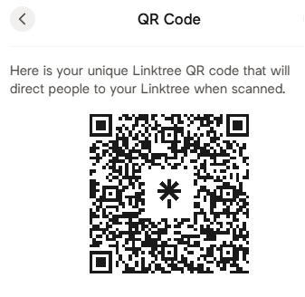

**Deployment Workshops: By Appointment**

Get the skills and resources needed to prepare for and manage the realities of separation and reintegration.

**Volunteer Orientation: By Appointment**

Discover volunteer opportunities at the Fleet and Family Support Center with flexible schedules and diverse learning experiences.

**Relocation Workshops: By Appointment**

Whether you are settling in or departing from a duty station, the relocation program can make the transition easier for you and your family.

